Water and Sanitization

The quality of water is deteriorating day by day because of the pollution that are
beign generated by the human necessity work. The quality is in such quality that
would lead to the health ill and other side effects to.

The water report is of 1st april,2012 in which is states that the contamination of
water on the particular day, and will go on increasing day by day. Due to which a
large scale of people have suffered and will continue to suffer. The states of
India with its districts, blocks, village have been affected, and the pollutants that
leads to contamination are :- Arsenic , Fluoride ,Iron , Nitrate , Salinity.
The count of affected habitations are :- Arsenic - 4,314 , Fluoride - 17,986 , Iron
- 56,144 , Nitrate - 2,758 and Salinity - 22,958.

The water report serves several purpose, including -

- The interrelation of the states affected by the quality deterioration of water, in
which rajasthan resembels to be on the top.

- Majority of the villages affected by the contamination but not on the severe basis
except the villages of tamil nadu.

= Majority of the habitation which have been affected by the contamination of
fluoride , then follows arsenic and iron has very less percentage.

Data Visualization on water and sanitization
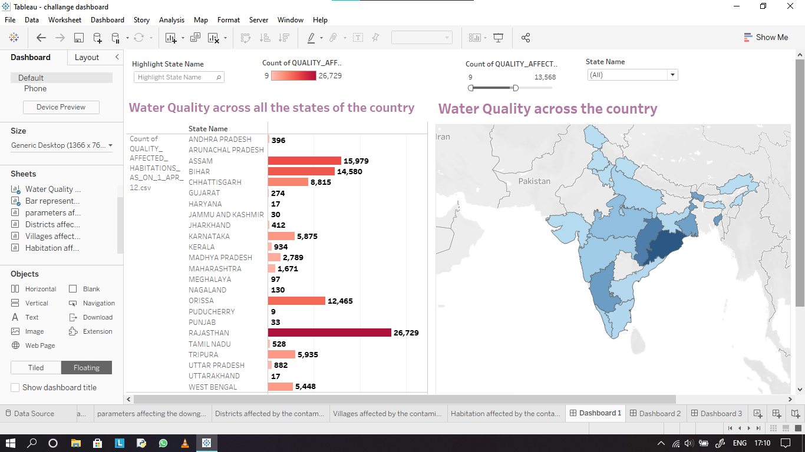

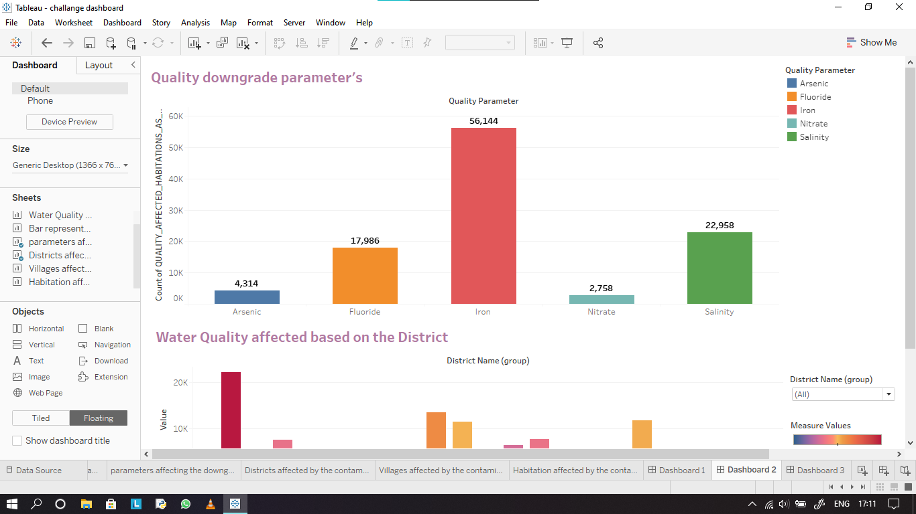

Reference URL:-

https://data.gov.in/catalog/water-quality-affected-habitations?filters%5Bfield_catalog_reference%5D=94688&format=json&offset=0&limit=6&sort%5Bcreated%5D=desc

